Year 7 Independent Learning Booklet
Medieval Monarchs
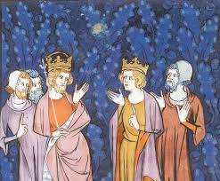

Section | Time allocated | Complete
William I | 30 minutes
William II | 30 minutes
Henry I | 30 minutes
Henry II | 30 minutes
King John | 30 minutes
Edward III | 30 minutes
Henry IV | 30 minutes
Overview | 30 minutes
Essay: Introduction | 15 minutes
Essay: Paragraph 1 on King John | 15-30 minutes
Essay: Paragraph 2 on an additional king | 15-30 minutes
Essay: Paragraph 3 on an additional king | 15-30 minutes
Essay: Paragraph 4 on an additional king | 15-30 minutes
Essay: Conclusion | 20 minutes
Task: In this booklet you will be researching and learning about the Medieval rulers of England. You will need to research and record key facts about their reign, the successes they had and then decide for yourself whether they were successful monarchs and which monarch was most successful. You will then create an essay based on the success of the monarchs. You will be answering the question:
‘King John was the most successful Medieval Monarch.’ How far do you agree?
You will need to include:
Introduction- What skills did a Medieval king need to have? What makes them successful?
Paragraph 1: King John- why was he successful? Why is he not successful?
Paragraph 2: Any king that you think was successful- explain why they were more successful than John.
Paragraph 3: Any king that you think was successful- explain why they were more successful than John.
Paragraph 4: Any king that you think was successful- explain why they were more successful than John.
Conclusion: Overall- do you agree with the statement and why?
The lines show parent child relationship, horizontal lines show siblings
The names in boxes are the men who were King of England
The = sign shows who they are married to

Task: complete the spider diagram below to show the key skills a Medieval King would need

Key skills or characteristics of Medieval Kings

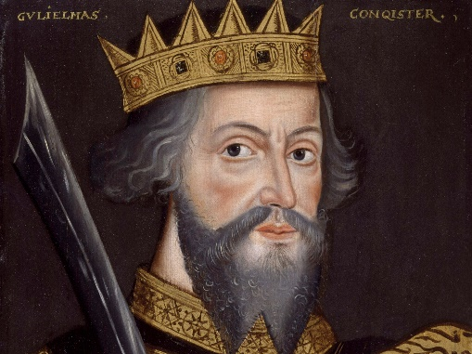
William I

What years did William I rule England?

What is his more famous nickname?

What famous battle meant William became King of England?

Who did he defeat in that battle?

Key features of William’s reign:
- What was the Domesday book? When was it made? Why?

- What was the Harrying of the North? Why did William carry this out?

- William built Norman castles during his reign… List 5 features of Norman Castles, what is the purpose of each feature:

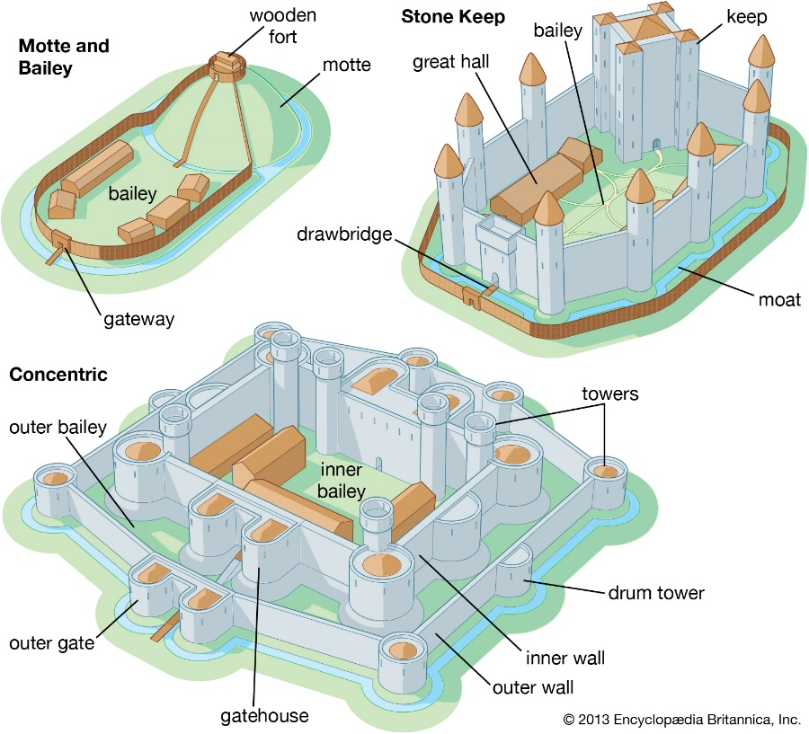

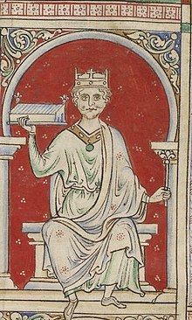
William II
William was born in around 1056 and almost nothing is known about his childhood. At his death in 1087, William gave England to William, his third and favourite son, who was crowned in September 1087. In 1088, William faced a rebellion inspired by his uncle, Odo of Bayeux, in favour of Robert – William II’s older brother. But Robert failed to appear, and the revolt soon collapsed. In 1089, William tried to take over Normandy in France and started a war against Robert, who he successfully defeated.
William faced opposition from Scotland and in 1091 he forced Malcolm III, King of the Scots to recognise him as his king. Malcolm revolted in November 1093, but William's forces crushed his army near Alnwick and Malcolm was killed. Thereafter, William maintained the support of the Scottish Kings.
William also had difficult relations with the church he had numerous arguments with Anselm, Archbishop of Canterbury from 1093. When Anselm left for Rome in 1097 to seek the advice of the pope, William took all his land and houses.
On 2 August 1100, William died when he was shot by an arrow while out hunting. It was accepted as an accident but could have been an assassination. It has been suggested that his alleged killer, Walter Tirel, was acting under orders from William's younger brother, Henry, who promptly seized the throne as Henry I.
Questions:
What years was William II king of England?

Why was he not expected to be King of England?

Why did his father choose him as King of England?

How did William II ensure he maintain control of Scotland?

What problems did William II face with the church?

How did he die?

Do you think William I or William II was a better king? Why?

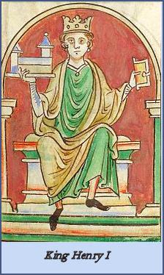
Henry I
Henry I was the fourth son of William the Conqueror and Matilda of Flanders and was born between May, 1068 and May, 1069 probably at Selby in Yorkshire.. On the death of his father, Normandy was given to his eldest son, Robert Curthose , England was left to the third son, William Rufus (William II) (a second son, Richard, had been killed whilst hunting in the New Forest) and to the youngest, Henry, he left a large sum of money.
Henry seized England's crown on the death of his brother, William II on 2 August 1100. He had been present on the hunting expedition in the New Forest which resulted in William’s death, either by accident or design and left quickly to seize the treasury at Winchester. Henry was accused of being involved in his brother’s death as he refused to allow Henry to marry the (half Saxon) Scottish Princess Edith.
Although he had many illegitimate children, Henry had only two children by his wife, Edith. A son, William, and a daughter Matilda, Tragedy struck when Henry's only remaining legitimate son, William, was drowned in the English Channel in the wreck of the White Ship. William had got away in a lifeboat but went back for his illegitimate sister, the Countess of Perche, when his boat was overturned. In the hope of getting another male heir to secure the succession, the King married for a second time to the young and beautiful Adelicia of Louvain, but the marriage produced no children.
In 1135, Henry again crossed to Normandy to see his two grandsons. During his visit, he quarrelled violently with his daughter Matilda and her husband. Henry was now an ageing king, these quarrels with his daughter affected him badly and he died in Normandy on 1st December 1135 at St. Denis le Fermont, from food poisoning, due to over indulging of his favourite dish of lampreys, which his doctors had forbidden him.
Task: Complete the table below selecting evidence from the story above to show whether Henry I was an unlucky king or a foolish king who made many mistakes:
Evidence of Henry I being unlucky | Evidence of Henry I making mistakes
Was Henry I unlucky or did he make many mistakes?
Henry II
The most famous event during the reign of Henry II was the murder of Thomas Becket.
Thomas Becket's life and death were remarkable. In 1162 he was appointed Archbishop of Canterbury by Henry. He became a strong defender of the Church and the rights of men who worked in the church. This was not the loyalty Henry had expected from Becket. At the time the Church held great wealth and power over monarchs and their people. With the support of the Pope in Rome, Becket represented an even greater power.

Becket also enjoyed the support of the people. Every village and town had priests and churches that were the centre of all life. Health, holidays, learning and the “gateway to heaven” revolved around devotion to the faith. The Church as guardians of all this, held great power and influence over the people. Any action against the Church was certain to bring punishment against the guilty person and his people - even if that action was taken by a king. The Becket affair was an argument between the king and the Church about power. It ended in notorious circumstances, with Becket beheaded in Canterbury Cathedral in 1170.
Henry viewed Becket as a nuisance, “the turbulent priest”, but Becket has been viewed as an example and martyr to religious people and was canonised almost immediately after his murder. Becket has been the subject of debate ever since his death: was he a saint or a troublemaker?
In 1174 Henry II did penance at Becket's tomb, but by then the damage to Henry's reputation was done.

Task: Write definitions for the following words or phrases:
- Archbishop of Canterbury
- Monarch
- Nuisance
- Martyr
- Canonised
- Penance
Who do you think was the blame for the murder of Thomas Becket? Was it Becket for not being loyal to the King and angering him? Or was it the king who should have respected the church and Becket’s role?!
King John
Historians often argue over whether King John was a useless or just an unlucky king.
Task: Read all the reason why John was an unpopular king, then number them one to six to show which is the most important (1) to least important (6).

Task 2: For the box you labelled as the least important – explain below why you think this is the least important?
Task 3: for the box you labelled as the most important – Explain below why you think this is the main or most important reason why John was unpopular.
Task 4: Using the information here and the boxes above decide for yourself whether you think John was unlucky or useless – Explain why.
In 1199, King John inherited the throne from his brother Richard I.
Potential problems:
- In order to take over French land John had to promise to be loyal to the King of France, but the King of France didn’t want John to be king
- John’s brother, Richard I, had left huge problems from John to sort out, as he had been away fighting and the barons had gained lots of power, which they didn’t want to give up
- Richard’s wars had been expensive, and the country was left with little money.
Edward III
Edward III is often considered a very successful medieval King. However, his reign did not begin well. His mother Isabella forced his father (Edward II) to give up the throne, and he later died in Berkeley Castle, probably murdered on the orders of Roger Mortimer, Isabella’s lover. The young Edward III was crowned King of England in 1327 when he was 14 years old. He was considered too young to govern England by himself, so his mother and Roger Mortimer governed for him. This was not a good arrangement. In 1330, Edward III had Mortimer arrested. He was thrown in the Tower of London and executed without trial. Edward was not in control.

Task: Write a paragraph explaining why Edward was a strong King. Use evidence from the picture above to support your points.
Henry VI
Henry VI is often considered a very weak medieval King. He was nine months old when his father, Henry V, died from dysentery (severe diarrhoea) while campaigning in France. The baby Henry inherited the throne of England.

Task: What one thing would you pick out a being the most important in making him a weak King? Write a paragraph to explain why you chose this

Task 2: Do you think Henry VI was a weak king or not? Use the table above to explain why you think this.

Medieval Monarchs overview:
- Name two medieval kings that were murdered?

- Name two medieval kings who died naturally?

- Which King do you think was most successful in battle? Why?

- Name any Kings who extended their kingdom by winning land in France?

- Which King do you think was most successful? Why?
Extension: Create fact files on any of the monarchs which were not included in this pack

